Delta Vs Qbeast Performance
Ask
The task was to benchmark Delta Lake and Qbeast performance using a dataset of accounts, measuring both query execution time and storage size across different formats:
- Standard Delta
- Partitioned Delta
- Qbeast (with indexing on state and asset_class)
The goal was to understand how Qbeast indexing affects performance compared to Delta in operations such as full scan, filtered queries, aggregations, and sampling.

Scope
- Input Data: Accounts dataset loaded from CSV (joined_table900_csv.csv).
- Formats Tested: Delta, Delta (Partitioned by asset_class), and Qbeast.
- Operations Benchmarked:
  - Write performance
  - Storage size comparison
  - Full scan row count
  - Filtered count (state = 'California' AND current_balance > 10000)
  - Aggregation (AVG(current_balance) grouped by asset_class)
  - Random sampling (10%)
- Outputs:
  - Execution time report (_time.csv)
  - Storage size report (_storage.csv)
  - Markdown summary tables

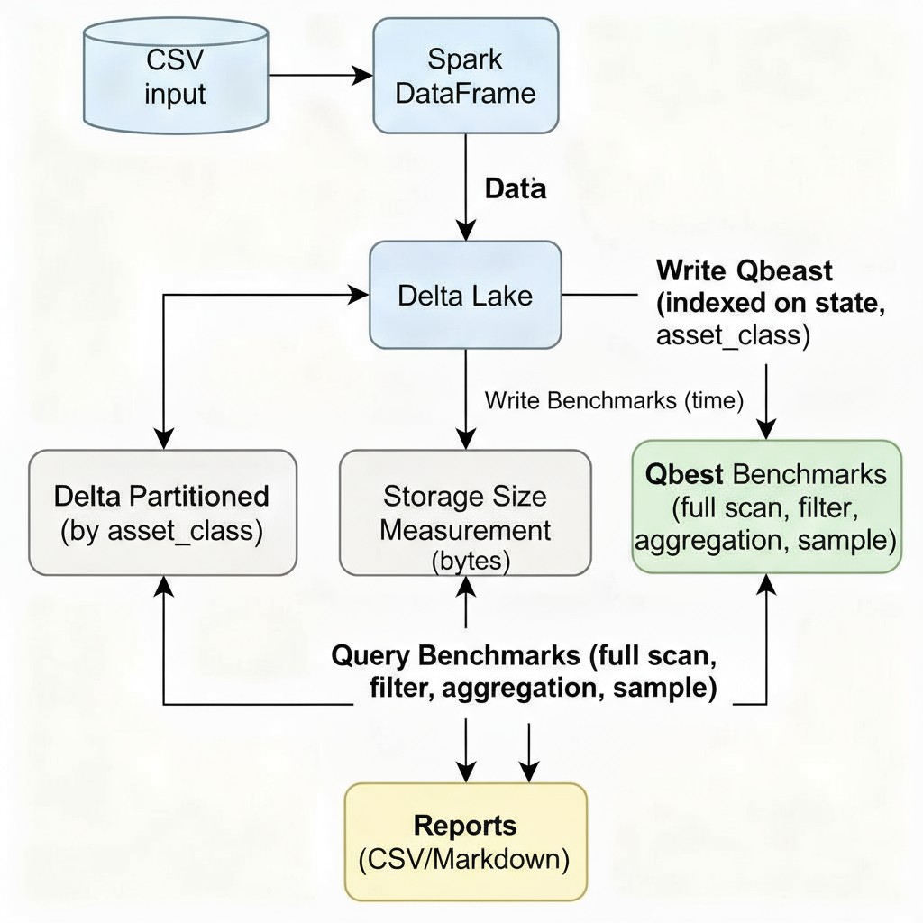

1. Data Loading
- The process begins by loading the accounts dataset CSV into a Spark DataFrame.
- This step reads raw data and prepares it for benchmarking.
2. Data Writing
- The data is then written in three different formats:
  - Delta Lake (regular): Stores data in the Delta format.
  - Delta Partitioned: Same as Delta, but data is partitioned by asset_class for query optimization.
  - Qbeast: A Delta Lake extension that adds multi-dimensional indexing on state and asset_class columns.
3. Storage Size Measurement
- After writing, the storage size for each format is measured by calculating the folder size on disk.
- This quantifies the storage overhead or savings of each approach.
4. Query Benchmarking
- Benchmark queries run against each format, measuring execution time:
  - Full Scan Count: Counting all rows, representing worst-case query.
  - Filtered Count: Counting rows filtered by state = California and current_balance > 10000 to test selective reads.
  - Aggregation: Calculating average current_balance grouped by asset_class to test group operations.
  - Sampling (10%): Randomly sampling 10% data to test quick approximate queries.
5. Results Collection
- Execution times and storage sizes are recorded and compiled into separate CSV report files:
  - benchmark_report_accounts_time.csv for query and write durations.
  - benchmark_report_accounts_storage.csv for disk usage.
6. Reporting
- The final step produces Markdown tables summarizing performance and storage efficiency side-by-side for easy comparison.

Conclusion
- 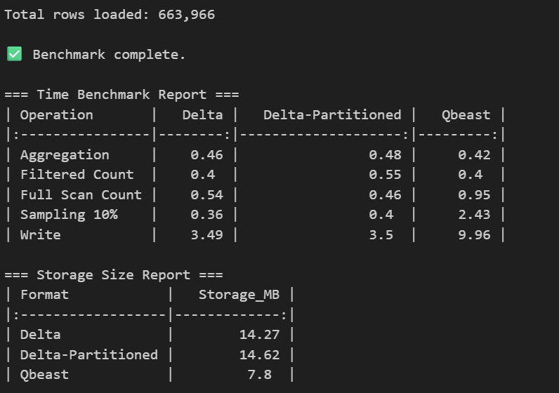

Reasons for Qbeast metrics
1. Write Operation
- Qbeast takes significantly longer to write because it builds spatial indexes on selected columns (state, asset_class).
- This write-time index organization involves extra sorting and metadata generation, introducing overhead compared to Delta’s simple append.
2. Full Scan
- For full scans, Qbeast does not provide pruning advantage.
- All index cubes must be touched, and the overhead of traversing the index structure can make a full scan slower than Delta, which simply reads records sequentially.
3. Sampling (10%)
- Qbeast uses its index to identify relevant cubes for sampling.
- While this accelerates selective and approximate queries on massive datasets, it can introduce extra computation and disk seeks for small samples on relatively small datasets, sometimes making basic sampling slower than a straight scan in Delta.
- On very large datasets, Qbeast’s sampling usually becomes much faster than Delta, but for moderately sized sets, the index construction and lookup cost can dominate.

